Curriculum Vitae

Name: Prabhat Mishra 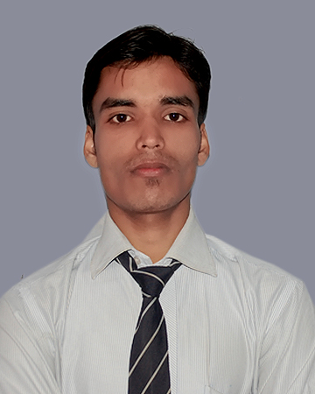
Contact number: +91-7042724157

e-mail address: prabhatmishracs@gmail.com

Objective

To work in a challenging environment where I can apply my professional skills and interpersonal abilities to deliver top results to help a organization expend further and to help myself grow further professionally, technically, and financially.

Professional Qualifications:

Completed B.Tech in Computer Science & Engg. from Gautam Buddh Technical University (UPTU), Lucknow from S.R.Institute of Management & Technology B.K.T, Lucknow.

First Year | 60.1%
Second Year | 62.75%
Third Year | 63.35%
Final Year | 73.8%

Technical Skills:

Languages Known: ASP.NET .
Database: SQL Server 2008.

Project Undertaken:

- B.tech final year project: “Employment zone”
This is my B.Tech final year project.It is like a job portal and in this portal main thing is to provides the various vacancies for jobseeker.
Area of Interest:

- In study of Database Management System.

Extra Curriculum activities:

- Joined 2 days workshop of Ethical Hacking.
Work Experience:

- Excellence award for Academic performance (B.tech 2nd & 3rd year).

Hobbies :

- Playing Chess,Watching movies and listening all type of Hindi songs but slightly partial to new songs.
- Internet surfing, Reading.
Personal Details:

- Name : Prabhat Mishra
- Date of birth : 20th mar 1995
- Gender : Male
- Mother’s Name : Mrs. SUMAN MISHRA
- Father’s Name : Mr. SHIV GANESH MISHRA
- Nationality : Indian
- Permanent Address : 418/583,New kalyanpuri thakurganj Lucknow.
- E-mail : prabhatmishracs@gmail.com

Declaration

I do hereby confirm that the information given above is very much true to the best of my knowledge.

Date:

Place: Lucknow (PRABHAT MISHRA)

